**INDEX**

|  |  |  |  |  |  |
| --- | --- | --- | --- | --- | --- |
| S.No. | Name of the Experiment | Date | Page No. | Marks  Awarded | Remarks |
| 1 |  |  |  |  |  |
|  |  |  |  |  |  |
|  |  |  |  |  |  |
|  |  |  |  |  |  |
|  |  |  |  |  |  |
|  |  |  |  |  |  |
|  |  |  |  |  |  |
|  |  |  |  |  |  |
|  |  |  |  |  |  |
|  |  |  |  |  |  |
|  |  |  |  |  |  |
|  |  |  |  |  |  |
|  |  |  |  |  |  |
|  |  |  |  |  |  |
|  |  |  |  |  |  |
|  |  |  |  |  |  |
|  |  |  |  |  |  |
|  |  |  |  |  |  |
|  |  |  |  |  |  |
|  |  |  |  |  |  |
|  |  |  |  |  |  |
|  |  |  |  |  |  |
|  |  |  |  |  |  |
|  |  |  |  |  |  |
|  |  |  |  |  |  |
|  |  |  |  |  |  |
|  |  |  |  |  |  |
|  |  |  |  |  |  |

**OS RECORD**

**WEEK-1:**

**AIM:** Understanding and practical exposure towards Basic Linux commands.

**1. pwd**

* **Definition**: Displays the full, absolute path of the current working directory, starting from the root (/).
* **Syntax**: pwd
* **Command**: pwd
* **Output**:

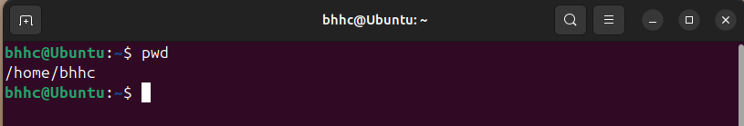

**2. cp**

* **Definition**: Copies files or directories from one location to another. Can also copy multiple files to a directory.
* **Syntax**: cp [options] source destination
* **Command**: cp file1.txt /home/user/backup/
* **Output**:

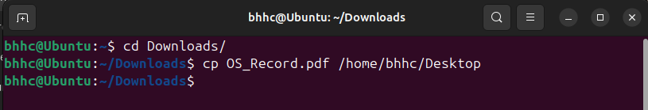

**3. locate**

* **Definition**: Searches for files and directories by name using an indexed database, making it faster than other search commands.
* **Syntax**: locate [pattern]
* **Command**: locate testfile
* **Output**:

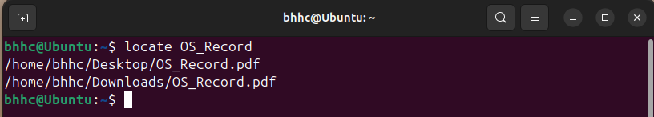

**4. kill**

* **Definition**: Terminates a process by sending it a signal, typically used to stop unresponsive programs.
* **Syntax**: kill [signal] PID
* **Command**: kill
* **Output**:

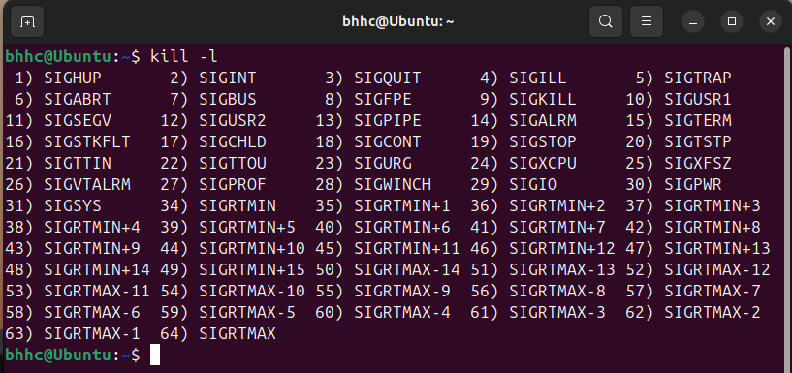

**5. cd**

* **Definition**: Changes the current working directory to the specified directory. Can navigate using relative or absolute paths.
* **Syntax**: cd [directory]
* **Command**: cd /home/user/docs
* **Output**:

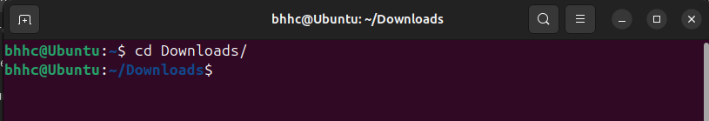

**6. mv**

* **Definition**: Moves or renames files and directories. Can transfer files between directories or update their names.
* **Syntax**: mv [source] [destination]
* **Command**: mv old.txt new.txt
* **Output**:

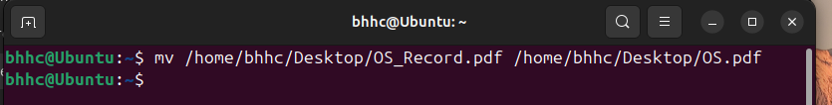

**7. find**

* **Definition**: Searches for files and directories based on conditions like name, size, or permissions, and performs actions on them if specified.
* **Syntax**: find [path] [options] [expression]
* **Command**: find /home -name "*.txt"
* **Output**:

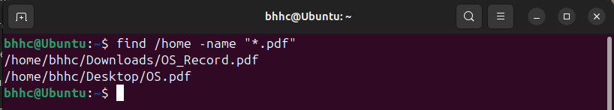

**8. chmod**

* **Definition**: Modifies the read, write, and execute permissions of a file or directory for the user, group, and others.
* **Syntax**: chmod [permissions] [file]
* **Command**: chmod 755 script.sh
* **Output**:

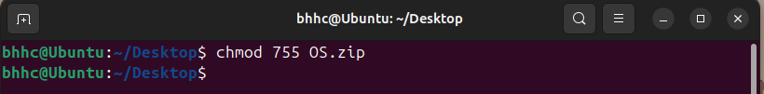

**9. ls**

* **Definition**: Lists the files and directories in the current or specified directory, with options to show hidden files or detailed metadata.
* **Syntax**: ls [options] [path]
* **Command**: ls -l
* **Output**:

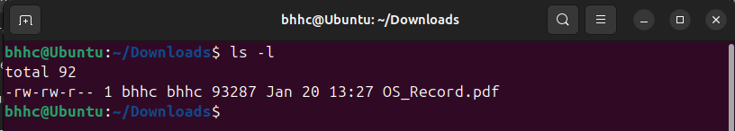

**10. mkdir**

* **Definition**: Creates a new directory. Can also create parent directories if they do not exist.
* **Syntax**: mkdir [options] directory
* **Command**: mkdir new_folder
* **Output**:

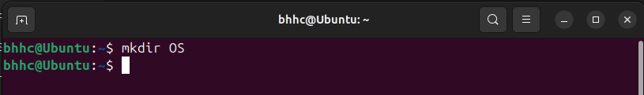

**11. grep**

* **Definition**: Searches for a specific text pattern in files or output streams and highlights matching lines.
* **Syntax**: grep [options] pattern [file]
* **Command**: grep "error" logfile.txt
* **Output**:

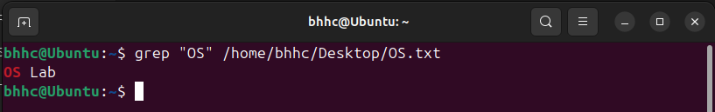

**12. echo**

* **Definition**: Displays a string or variable value to the terminal. Commonly used in scripts.
* **Syntax**: echo [string]
* **Command**: echo "Hello, World!"
* **Output**

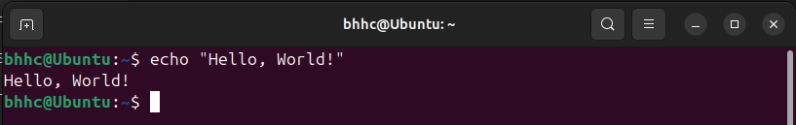

**13. cat**

* **Definition**: Displays the content of a file, combines multiple files, or creates new files.
* **Syntax**: cat [file]
* **Command**: cat file.txt
* **Output**:

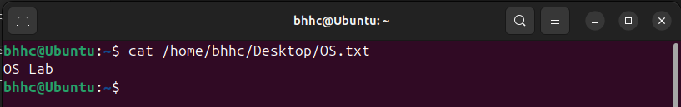

**14. rmdir**

* **Definition**: Deletes empty directories. Will not work if the directory contains files or subdirectories.
* **Syntax**: rmdir [directory]
* **Command**: rmdir empty_folder
* **Output**:

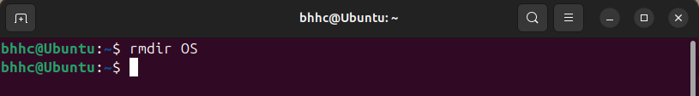

**15. man**

* **Definition**: Displays the manual page for a command, detailing its purpose, options, and examples.
* **Syntax**: man [command]
* **Command**: man ls
* **Output**:

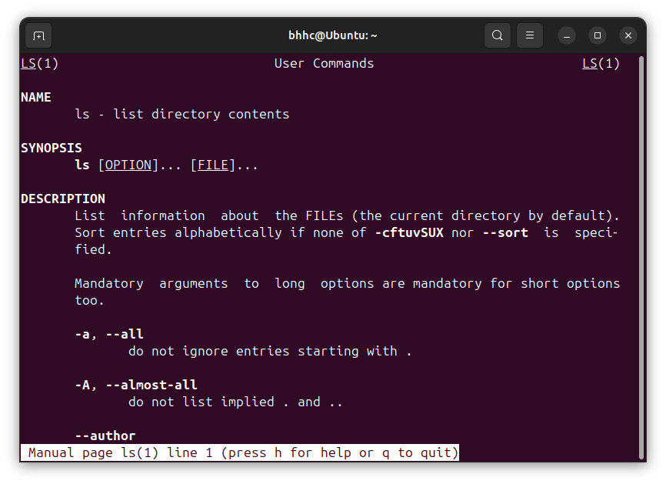

**16. hostname**

* **Definition**: Displays or sets the hostname of the system, used for network identification.
* **Syntax**: hostname
* **Command**: hostname
* **Output**:

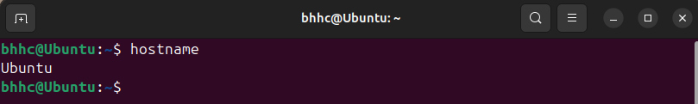

**17. rm**

* **Definition**: Deletes files and directories. With options, can recursively remove directories and their contents.
* **Syntax**: rm [options] file
* **Command**: rm file.txt
* **Output**:



**18. tail**

* **Definition**: Displays the last few lines of a file, commonly used to monitor logs.
* **Syntax**: tail [options] [file]
* **Command**: tail file.txt
* **Output**:

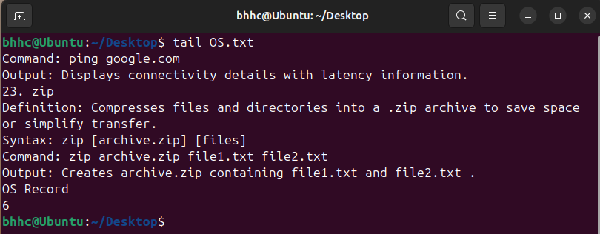

**19. jobs**

* **Definition**: Lists all active or suspended background jobs in the current shell session.
* **Syntax**: jobs
* **Command**: jobs
* **Output**:

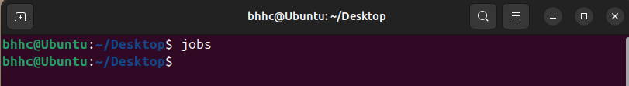

**20. uname**

* **Definition**: Provides basic information about the system, such as the kernel name and version.
* **Syntax**: uname [options]
* **Command**: uname -a
* **Output**:

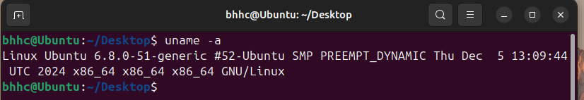

**21. history**

* **Definition**: Displays a list of previously executed commands in the terminal session.
* **Syntax**: history
* **Command**: history
* **Output**:

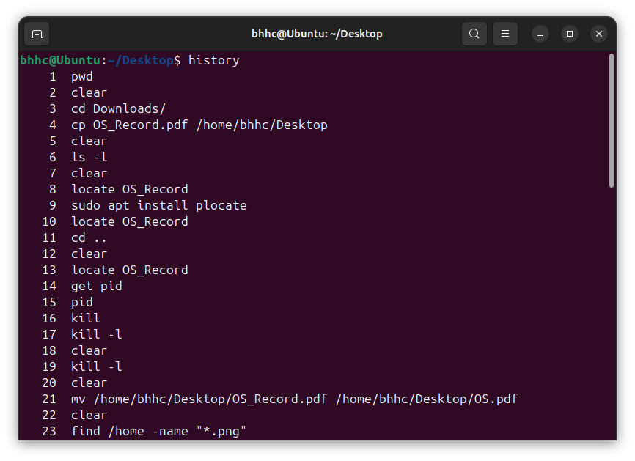

**22. ping**

* **Definition**: Tests network connectivity by sending packets to a specified host and measuring the response time.
* **Syntax**: ping [host]
* **Command**: ping google.com
* **Output**:

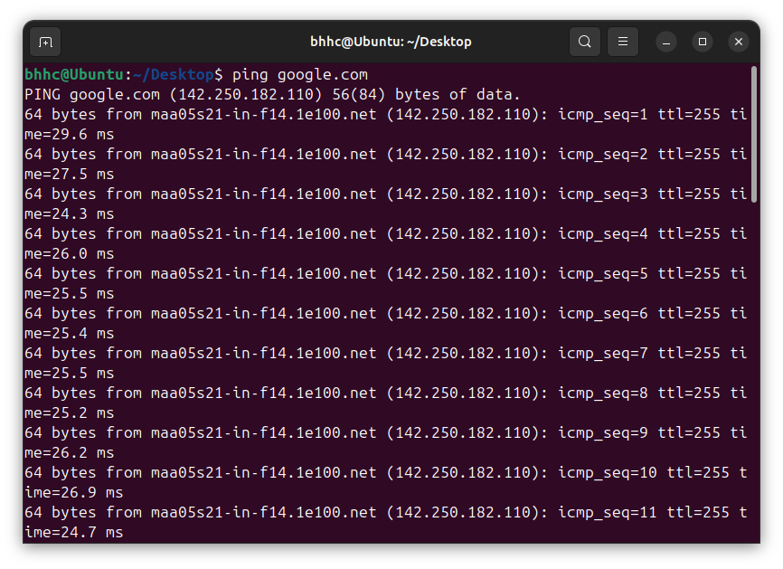

**23. zip**

* **Definition**: Compresses files and directories into a .zip archive to save space or simplify transfer.
* **Syntax**: zip [archive.zip] [files]
* **Command**: zip archive.zip file1.txt file2.txt
* 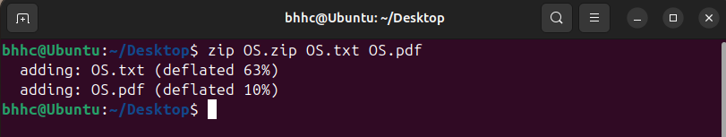**Output**:

**WEEK-2:**

**AIM:** Collect the basic information about your machine using proc in Linux.